**4-blocker**

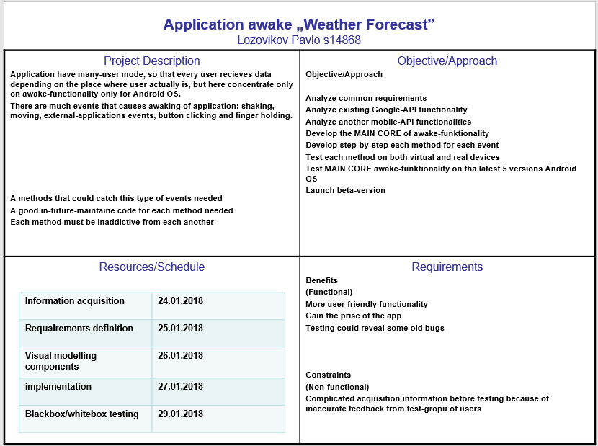

**Awake smartphone application (weather forecast)**

**Requirements - User Stories**

|  |
| --- |
| Title: waiting for event |
| AccTest: checkExternalEvent() Priority: 1 Story Points: 2 |
| When applicayion is not in use per long time, it’s in the „sleep” mode and waiting for some events. There are four different options for launch application: 1) shake your phone, 2) push the „on/off” button, 3) hold a finger on the touchscreen, 4) catch the event from another application. This method get data from each method described further. If one of those methods returns „true”, application starts immediately. |

|  |
| --- |
| Title: shake your phone |
| AccTest: checkShake() Priority: 1 Story Points: 2 |
| User can take the smartphone in his hand and this event will catched, so listener must every time check this event but not very often for economy battery. Income data depends on the OS. For android: FORCE_THRESHOLD, TIME_THRESHOLD, SHAKE_TIMEOUT, SHAKE_DURATION, SHAKE_COUNT. For every constant from list above there are differentvalues, and if check statement of this method returns true at least for one of them, application starts immediately. |

|  |
| --- |
| Title: push the „on/off” button |
| AccTest: checkButtonClick() Priority: 1 Story Points: 2 |
| User can push the „on/off” button at some moment.There are only two inputs: true/false. If button pushed, input data for method becomes „true” and application starts immediately. |

|  |
| --- |
| Title: hold a finger on the touchscreen |
| AccTest: checkFingerHold() Priority: 1 Story Points: 2 |
| User can hold his finger upon the touchscreen. Income data depends on the OS. For android: ACTION_DOWN, ACTION_POINTER_DOWN, ACTION_MOVE, ACTION_POINTER_UP, ACTION_UP. Check statement of this method returns „true” if at least one of this actions returns „true” and application starts immediately. |

|  |
| --- |
| Title: catch the event from another application |
| AccTest: checkExternalAppData() Priority: 1 Story Points: 2 |
| Another application installed on particularly this smartphone may have permissions to our application. Envoke this method depends on the type of the cathced external event, different for each one application. Permissions may have google chrome(default for parsing data) and some other applications like ours. Income data and abilities to fetch external data depends on OS. For android: add to „manifest.intent-filter” block separately for each one type of communication „SEND/GET/POST/SEND_MULTIPLY” and for each check type of action. If method returns true, application starts immediately. |

**Requirements – Use Case**

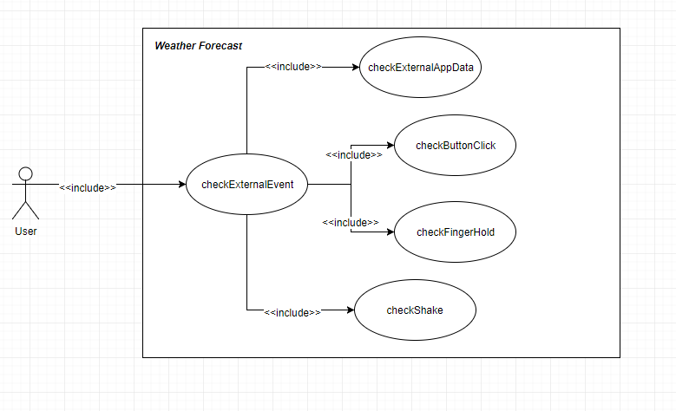

UC1: Flow of Events for the CheckExternalEvent  
1.1 Preconditions: Application is in the *sleep* mode  
1.2 Main Flow: The „Weather forecast” waits for the input data from at least one of the maintained events. There are 4 types of events that are maintained by [UC1]: 1) checkShake [UC2], 2) checkFingerHold [UC3], 3) checkButtonClick [UC4], 4) checkExternalAppData [UC5]

UC2: Flow of Events for the *checkShake*  
2.1 Preconditions: smartphone must come into movement  
2.2 Main Flow: A user shake or just take the smartphone in the hand [S1][S2]  
2.3 Subflows:

[S1] If user take phone very slowly, nothing will happen

[S2] If phone will moved only along the „X” axis (without „Y”), nothing will happen  
2.4 Alternative Flows: None